Objective: Manas, the flow diagram you have provided is genius and will be our roadmap for this semester. Many, many thanks for encapsulating highly technical processes into a simple, easy-to-comprehend diagram! This ability to demystify complex ideas will ensure your future success as a thought leader and visionary. Pleasure to work alongside you, sir
For this week, we will begin at Stage 3: Source collection.
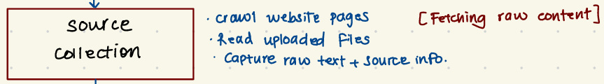
As you have mentioned in our emails, we will include the following scope of work under Stage 3: Source collection:
At Stage 3, the focus would be strictly on collecting and storing raw content from user-provided sources. This includes gathering the raw page or document content, extracting readable text, and capturing basic metadata such as source URL or file name, page title, and retrieval time. Importantly, this stage would stop at data collection and preservation, without performing cleaning, scoring, or AI-driven analysis yet.

At a high level, the diagram illustrates the following flow:
A user provides input in the form of a website URL, PDF, document, or text. The tool first validates the input and then collects the source content. This content is extracted and cleaned to remove noise such as navigation elements, ads, or duplicated text.

Thus, the aim for this week will be to develop a tool, which can web based or local, that can read users’ uploaded files (e.g., .pdf, .docx, .xlsx, .pptx) and capture raw content, readable text, and basic metadata. The extracted content should be stored in a way, such that it is usable for the subsequent stages of data cleaning, normalization, and preprocessing.
Deliverables: By Saturday, 1/31/2026, please email the following:
- Working prototype of an artifact that can read and ingest user data to capture text and other relevant source information (e.g., think of an artifact link Merge PDF that allows users to upload files). If the working prototype is web based, please provide the URL as a deliverable for human evaluation. If the artifact is hosted locally, please record a video through Zoom, Adobe, Kaltura, or any recording software, demonstrating your use of the tool. The video should include the uploading of various documents, an explanation of the procedures taking place, and a visual depiction of the stored output that will be used in the later stages.
Instructions: You will have complete autonomy to build the source collection artifact as you envision! I do not want to impose any restrictions on your imagination. Be as visionary as possible and do not feel compelled to operate within the boundaries established in the current AI visibility tool framework. In Week 1, you identified issues with the current tool that require improvements. Rather than appending our updates and improvements to the tool, if it is better for you to pick-and-choose the code that you need from the existing tool to then build from the ground up, then let’s please do that. I buy into your vision expressed in the flow diagram and foresee the development of a highly viable tool. We will build the tool incrementally (e.g., sprints), and when we feel we need additional human capital, access to APIs, additional software, or the like, please let me know, and I will help to procure them.
Importantly, have fun with this and tap into that brilliant mind of yours! As we are ideating and building a prototype, we can envision our most powerful tool. If we need to raise capital or apply for grants, then I can take those necessary steps.
Cheers, sir, and thanks so much for your time and amazing effort! Have a great week, Manas, and please let me know if you have any questions or concerns about the task.
Respectfully,
Nick

